**ROBOCUP ASIA-PACIFIC 2021**

**TEAM DESCRIPTION PAPER**

**(Cover Page)**

| League Name: | RoboCupIndustrial @Work |
| --- | --- |
| Age Group: | Major |
| Team Name: | BRC |
| Team Website: |  |
| Participants and  Technical Roles: | Khakimova Kristina - Gazebo programmer  Suhanov Mikhail – wheelbase programmer  Han Daniel - Data Science programmer  Linok Sergey – Data Science programmer  Romanov Rostislav – Robotic arm programmer  Peshnin Artyom - wheelbase programmer  Dudiev Valerian – Gazebo programmer  Pshibiev Arthur - Data Science programmer  Daukaev Ruslan - Data Science programmer |
| Team Photo |  |
| Mentor Name: | Shereuzhev Madin |
| Institution: | Bauman Moscow State Technical University |
| Region: | Russia |
| Contact Person: | Shereuzhev Madin |
| Contact Email: | [shereuzhev@gmail.com](mailto:shereuzhev@gmail.com) |
| Date: | 25.09.2021 |

**ROBOCUP ASIA-PACIFIC 2021**

**TEAM DESCRIPTION PAPER**

Major

RoboCupIndustrial @Work

Khakimova Kristina, Suhanov Mikhail, Han Daniel, Linok Sergey,

Romanov Rostislav, Peshnin Artyom, Dudiev Valerian, Pshibiev Arthur, Daukaev Ruslan

BRC, BMSTU, Russia

**Abstract**

BRС is a team of engineering students who want to try their hand at various competitions. We have been working as a team only this year, and the first world competition for us will be RoboCup 2021. We are students of two Russian universities: BMSTU and STANKIN.

The purpose of our participation in the competition is to gain practical skills in the development and programming of mobile robotic platforms. For a properly developing system, we needed to study algorithms for mapping, determining the robot's position in space. From the beginning, we had to write a program for using algorithms for recognizing, classifying, and localizing objects in the image.

To accomplish the task, we used: a mobile platform equipped with omni-wheels that allow you to move in any direction without turning the robot body, an angular-type manipulator with kinematics, a depth camera, 2 lidars, and 3 single-board computers.

**1. Introduction**

**a. Team**

● Team background, including website and video link (if you have).

● Brief description of roles of each participant in the team and past experiences.

Team roles:

* Khakimova Kristina - Gazebo programmer
* Suhanov Mikhail – wheelbase programmer
* Han Daniel - Data Science programmer
* Linok Sergey – Data Science programmer
* Romanov Rostislav – Robotic arm programmer
* Peshnin Artyom - wheelbase programmer
* Dudiev Valerian – Gazebo programmer
* Pshibiev Arthur - Data Science programmer
* Daukaev Ruslan - Data Science programmer

Our team members had the experience of participating in many completions, such as:

* Robocup junior rescue maze (Peshnin Artyom and Romanov Rostislav)

**2. Project Planning**

**a. Overall project plan**

● Our aim for the competition – Win and gain extra practical experience

1. Read and analyze the rulebook
2. Distribution of tasks
3. Work on a prototype
4. Debug and finalize models
5. Work with sensors and Lidars
6. Train a neural network for object recognition
7. The final test in Gazebo
8. Write an application for RoboCup

● How has analysing the task and its constraints influenced your project plan.

At the beginning of our work, we read the regulations a lot of times and began to distribute roles in the team based on the wishes of the team members. We identified three main tasks: navigation, manipulation, transportation, simulation. Then each person worked closely with their problem.

**b. Integration plan**

Our robot consists of a wheelbase and a robotic manipulator arm. The robotic arm is controlled by NanoPI SBC. Also, we have a depth camera (intel real sense) mounted on the manipulator. It is used for object detection. Image from camera is processed on Nvidia Jetson SBC. The main computing unit of our robot is Intel NUC. NUC gives commands to all other parts of the system. Moreover, it reads scans from 2 lidar sensors and creates a map of obstacles. All the system works with the help of ROS framework.

**c. Testing**

During the development process, we tested each module of the robotic platform. To test the algorithms of cartography, we launched the robot in the room where we were and built its map.

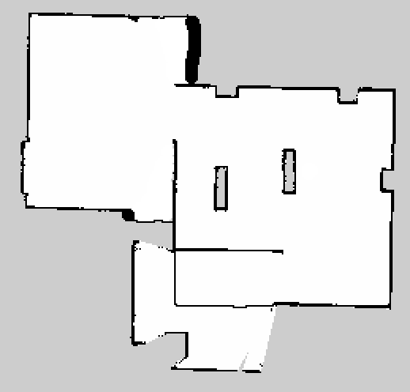

map of the testing room

To test the navigation algorithms, we used the Rviz utility: put a point on the map where the robot should reach and launch it. After training, the neural network was tested on ten images of objects.

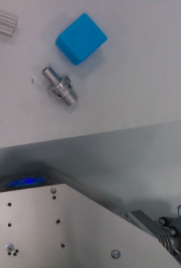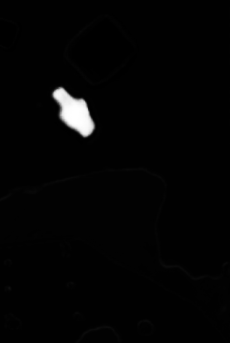

testing object recognition

Also, we have made a model of the test site in Gazebo, where we tested the robot model for movement. Then, in the process of training the neural network, we began to test the recognition algorithm. After our team did the debugging of the work of all components, we made final tests for the transportation of all these parts from the rulebook.

● Explain how you analyzed the test results and how they impacted your development

**3. Software**

**a. General software architecture**

The robot control program consists of several nodes, each of which is responsible for its task.

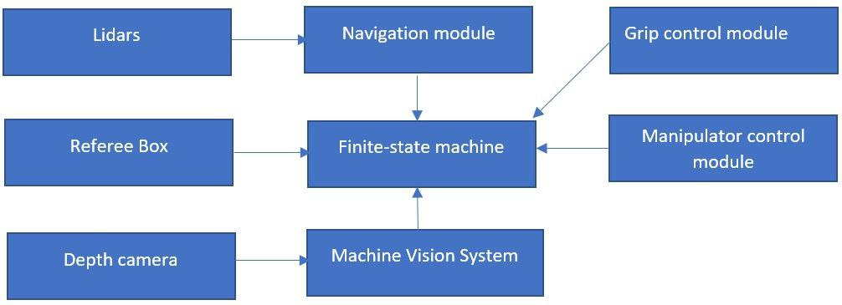

The main programming modules of the system

The manipulator control system is presented on the next image:

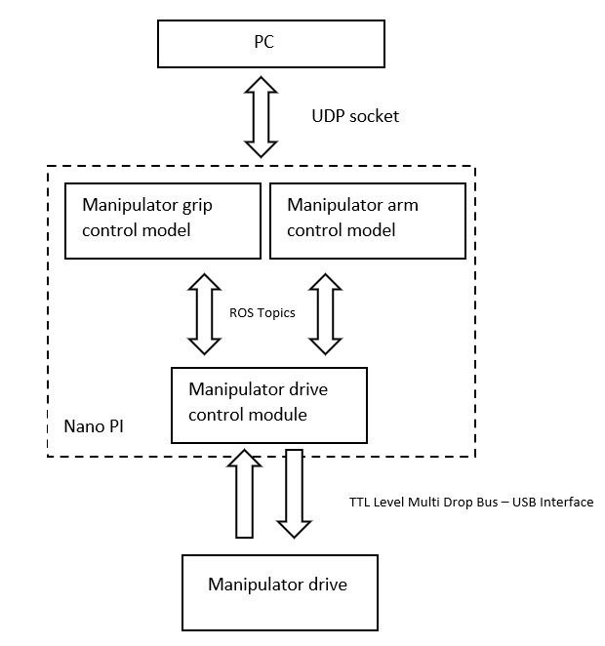

the control system of the manipulator

All nodes communicate with each other using the ROS framework. The data exchange diagram will be shown below.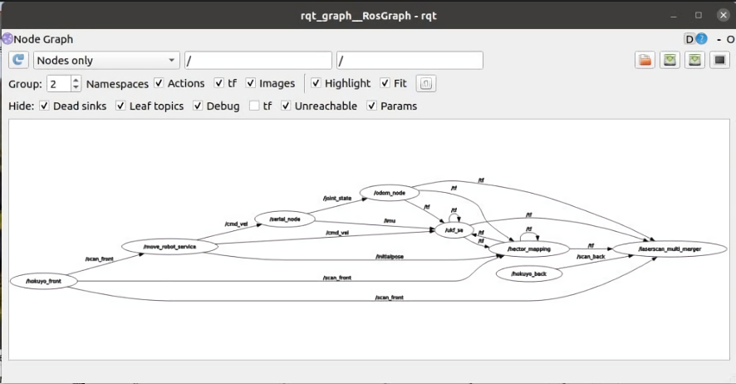

the scheme of nodes and their data exchanging

**b. Innovative solutions**

The entire structure and control modules of the robot are transferred to the Gazebo simulation, which allows to test and control the robot directly in the virtual working environment without interacting with the robot itself. We can also give commands to all the components of the machine in the simulation.

The low cost of construction and maintainability are the main advantages of our robot. For example, if one of the servos breaks down, it will be easy to replace it without any problems from the cost of parts.

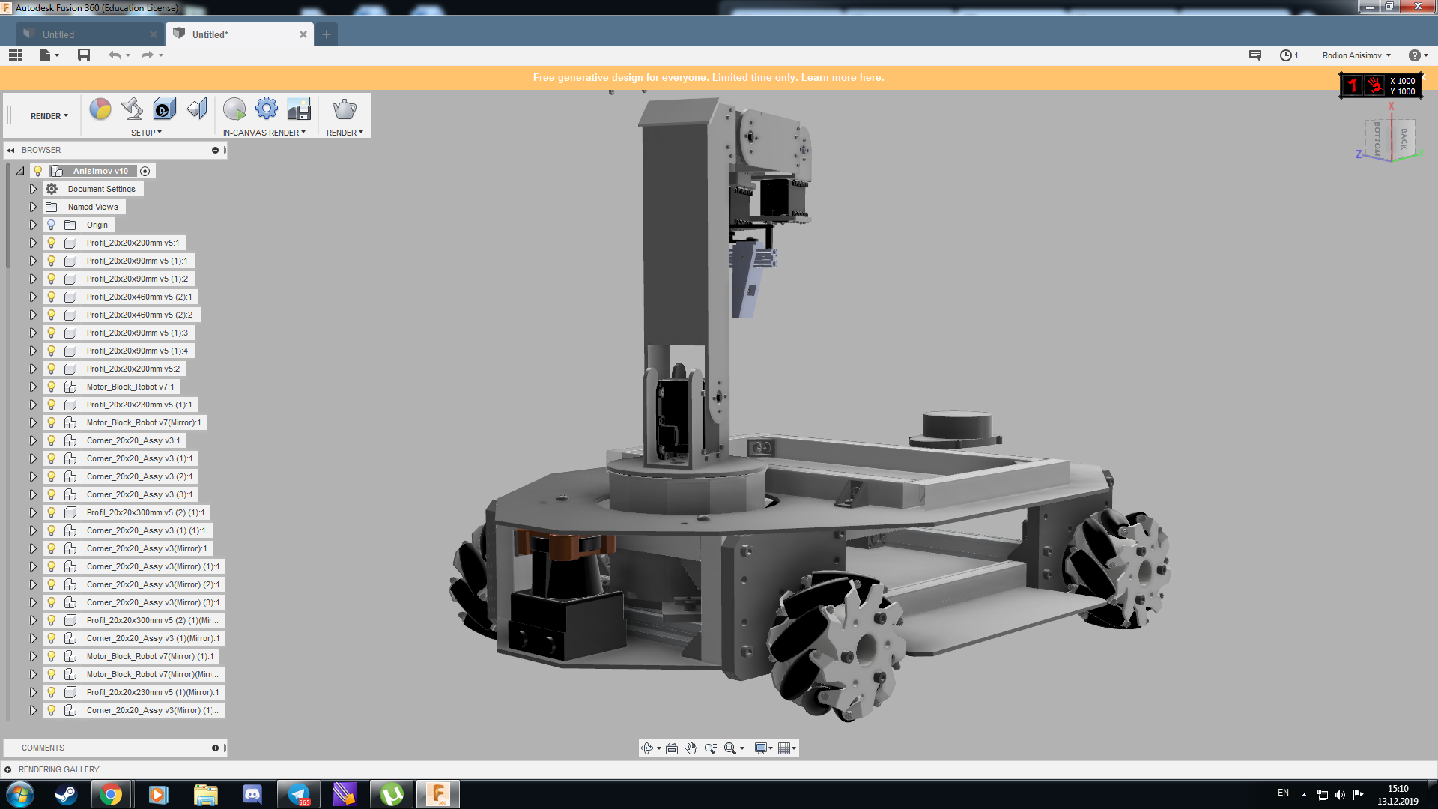

the CAD model (render) of the robot

**4. Hardware**

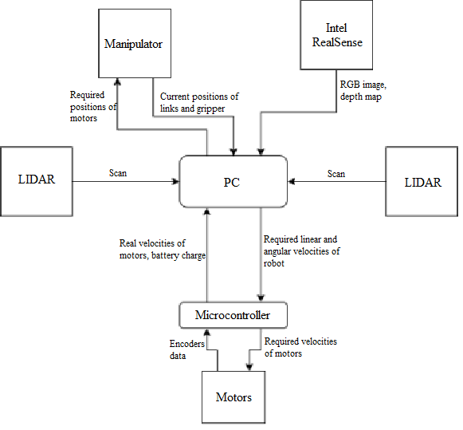

The scheme of the system control structure

● Give a high-level overview over the hardware design of your robot.

● Highlight important features and talk about how everything comes together.

**a. Mechanical design and manufacturing**

● Go into detail on aspects such as:

o Main structure

o The wheelbase of the robot is driven by 4 Dynamixel's servos. The manipulator is also driven by Dynamixel's servos.

All electronic components of the robot are powered by a 12v 10000ah lithium polymer battery. Also, the power system has a DC-DC converter from 12V to 5. It connects power to NanoPi and Nvidia Jetson.

o Important subassemblies/modules, etc.

o The robot has a forced stop button that turns off the power of the system.

(вставить фотографии составных элементов робота - динамикселей, аккумулятора, кнопки отключения питания)

**b. electronic design and manufacturing**

**вставить актуальную схему компонентов**

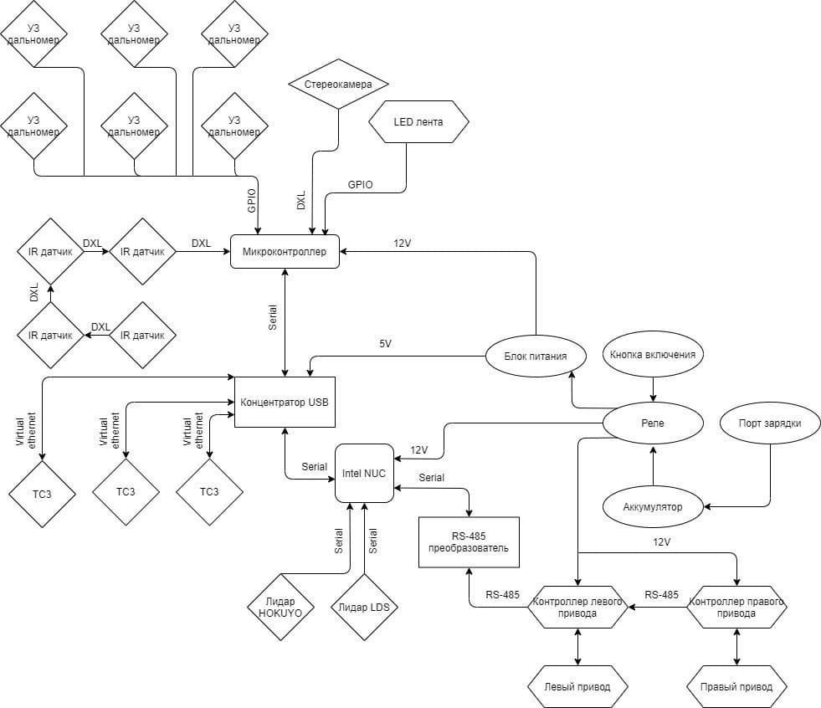

the scheme, which should be remastered

● Go into detail on aspects such as:

o Sensors

o Main controller

o Power subsystem, etc.

**5. Performance Evaluation (Result)**

● Evaluate the performance of your robot.

**6. Discussion and Conclusion**

● In conclusion, we would like to say that we learned a lot of new information in the process of the preparation for the RoboCup. Creating your robot and writing software for it is a laborious process. It was interesting for us to solve the tasks set for us in the regulations.

● Discuss on the impact of your hardware design / software algorithm to the project.

● In the process of developing software for the robot, we built the architecture of the robot control system, set up the mapping system, and dealt with the Gazebo simulation environment.

In the future, we plan to continue working with this robot. For educational purposes, we plan to try using other algorithms for trajectory planners. There are plans to test mapping algorithms using a binocular camera as the primary source of environmental data.

**8. References**

● References to external sources used for major parts of the development process.

//cделать гитхаб